Morse Decoder

|  |  |
| --- | --- |
| **Version** | **3** |
| **Issue Date:** |  |

|  |  |
| --- | --- |
| **Document Number:** |  |
| **Status:** |  |
| **CDRL No:** |  |
| **DOORS™ Module Reference:** |  |
| **Classification:** |  |

Sean Winfree



Table of Contents

Revisions 3

1.0 Introduction 4

2.0 Morse Code Timing 4

3.0 Morse Encoding 6

4.0 Morse Decoding 8

4.1 Hilbert Transform 8

4.2 Filtering 8

4.3 Filtering 8

5.0 References 9

**Table of Figures**

Figure 1: Dit and Dah Relative Timing 3

Figure 2: Character and Word Relative Spacing 4

Figure 3: Morse Code Time Domain 4

Figure 4: Morse Code (SNR = 10dB) 5

Figure 5: Performance of Morse Decoder 6

Revisions

The content of this document is wholly defined by the issue number and, where appropriate, the revision letter detailed below. The document will be reproduced in its entirety when any change has been incorporated and approved.

|  |  |  |  |  |  |
| --- | --- | --- | --- | --- | --- |
| Revision | Incorporated  by | | Revision  Date | Description of Change | CR(s)  Applied |
| - | Sean Winfree | | 9/10/2010 |  |  |
| 1 | | Sean Winfree | 9/20/2010 | Added Functional Flow Block Diagram |  |
| 2 | Sean Winfree | | 11/21/2010 | Added discussion on state machine and message examples. |  |
|  |  | |  |  |  |
|  |  | |  |  |  |
|  |  | |  |  |  |
|  |  | |  |  |  |

**Authorization Notification**

Prepared by: Sean Winfree, Chief Engineer

ASCEND;

Approved by: Sean Winfree, Chief Engineer

ASCEND

1. Introduction

The HF CW standard (also known as Morse code) is well known, and consists of a continuous phase – constant wave (CW) signal modulated as high or low to indicate the presence of a symbol. This mode of communication encodes ASCII characters as a series of bits with varying length and spacing. Short bits are known colloquially as "dits" (or dots) and will be represented here as a "." while long bits are known colloquially as "dahs" (or dash) and will be represented here as "dahs".

We use the well accepted international Morse Code standards, repeated here for convenience: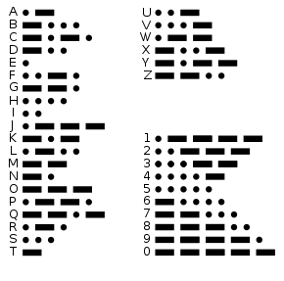

1. Morse Code Timing

Transmission speed, bit length and bit spacing define completely the aspects of the signaling. All other elements are defined as multiples of the dit length. Transmission speed in standard CW is measured in Words Per Minute (WPM). In our application, received WPM is restricted to be a single speed. The length of the average word is assumed to be 5 characters totaling 50 units. Using this value, we can compute the dit length as 1.2s/WPM and the dah length as three times this unit length. The in-character spacing is equal to one dit.



**WPM = 1.2s/(Dits per second)**

CW can be decoded by collecting short and long bits separated by in-character spaces (of length single dah) where characters may be separated by recognizing a between-word space (of length seven dits).

For example, a speed of 12WPM has an dit on time of 1.2/12 = 0.1 second. The subsequent dah length is then 0.3 seconds. Each on state is separated by the length of a dit, or 0.1 seconds in this example.

Figure : Dit and Dah Relative Timing

Figure 2 details, and between-character (letter) spacing is equal to three dits. The pausing between words is seven dits.



Figure : Character and Word Relative Spacing

The following table details the legal Morse Code letters allowed to compose a message.

Table - Variable Length Coding Scheme

|  |
| --- |
| 0: 1101  Q  1: 01    A  2: 1000  B  3: 1010  C  4: 100   D  5: 0010  F  6: 110   G  7: 0111  J  8: 0100  L  9: 0110  P |

A standard header to the message might look as follows:

UP QQAB C A Q ST X

Hdr message src dst fwd cmd terminator

counter

Note the spaces are intentionally used here to separate the fields. The Air Segment does not detect spaces (between, and as such space delimiting the fields is not required. Please note that the message field widths are fixed.

The decoding of the pulses into messages is handled by the . A detailed explanation of Air Segment message is available in the SW-005-01 ICD Messaging Interface.

1. Morse Encoding

The Morse on state is a Constant Wave (CW) of a defined frequency, fsig. The modulation (or carrier) frequency used to transmit the Morse code over HF is called the fcarrier. Figure 3 shows an example of a Morse code at baseband prior to being modulated by the carrier frequency. This is commonly referred to as the Morse CW signal.

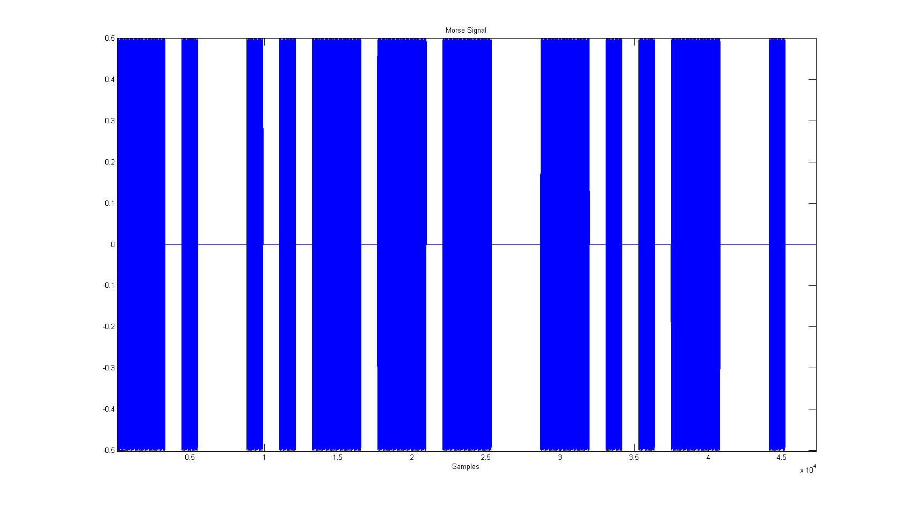

Figure : Morse Code Time Domain

To simulate the actual environment the Morse Decoder will be functioning, white Gaussian noise is added to the Morse CW signal.

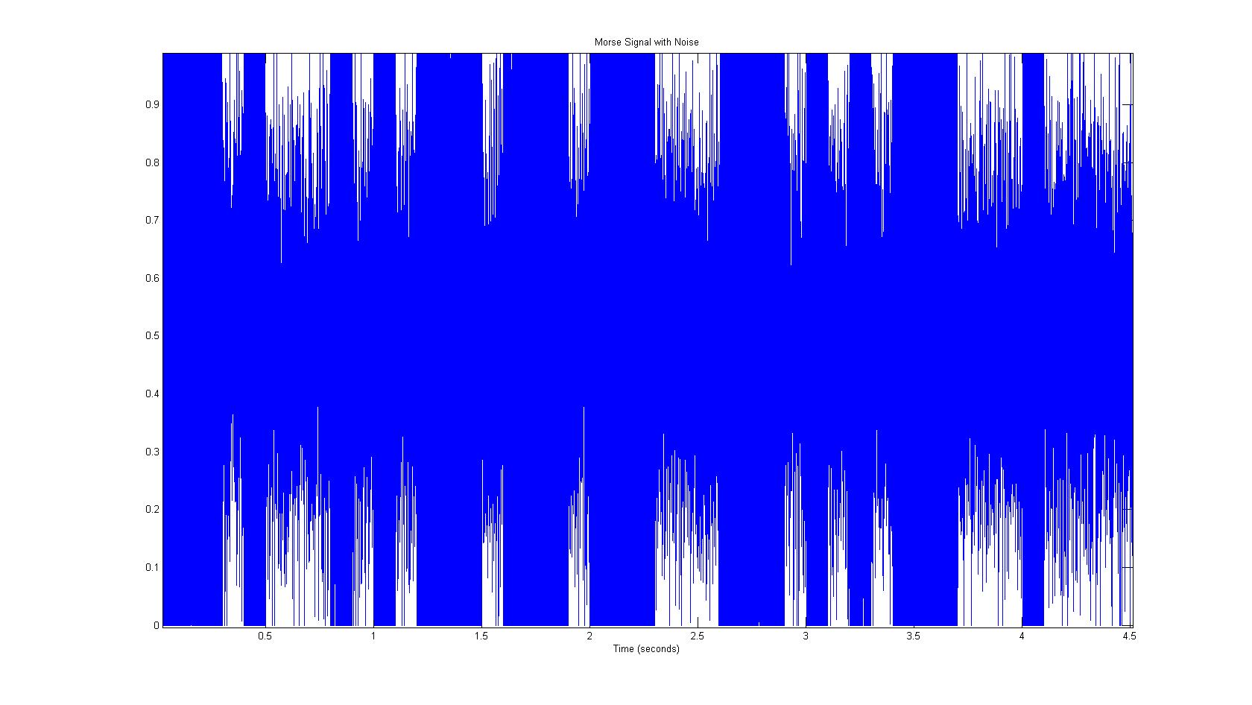

Figure : Morse Code (SNR = 5dB)

1. Morse Decoding

The received HF is converted to baseband by the HF transceiver. This signal is then scaled from the transceiver voltages to a level that can be handled by a typical Analog to Digital converter (ADC). The ADC samples the received signal x[n] at a rate of fsample. The expected frequency of the CW signal is fsig.

The sampled single, x[n], is processed by transforming the signal to baseband, filtering, summing real and imaginary parts, and averaging the results. Figure 5 details the processing applied to the sampled signal.



Figure : Morse Decoder - Signal Processing

* 1. Frequency Shift Transform

The frequency shift applied to the sampled signal x[n], shifts the frequency spectrum by the frequency of the desired CW signal. Essentially the frequency of the signal is shifted to baseband (DC). The DC noise band is then shifted by the same amount. The shift enables the use of simple low pass filters rather then pass-band filters.

Figure 6: Frequency Effects of Algorithm details the original Morse Code CW frequency response, the response after the frequency shift, and then the response after the low pass filter. Note that both the negative frequency band and the DC noise are removed from the signal after the filtering.

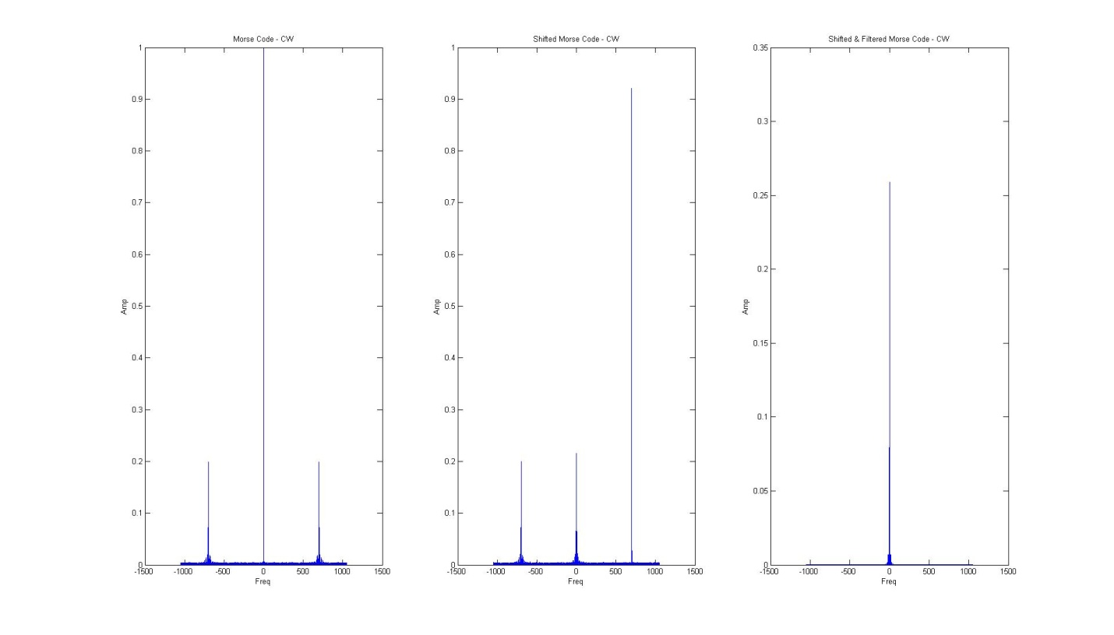

Figure : Frequency Effects of Algorithm

* 1. Low Pass Filtering

The real and imaginary signals are filtered with identical low pass FIR filters. The filters are generated using the MATLAB filter design functions.

* 1. Window Averaging Filtering

The window averaging filter, a simple averaging of a sample to its nearest neighbors, is then used to remove spurious results in the time-domain signal. The middle element of the window is replaced with the average of all the elements in the window. However, the update to the center value is not made until the window has passed.



Figure : Window Averaging Example

The Figure 8: Effects of Window Averaging Filter shows the effects of the Window Averaging Filter on the signal.

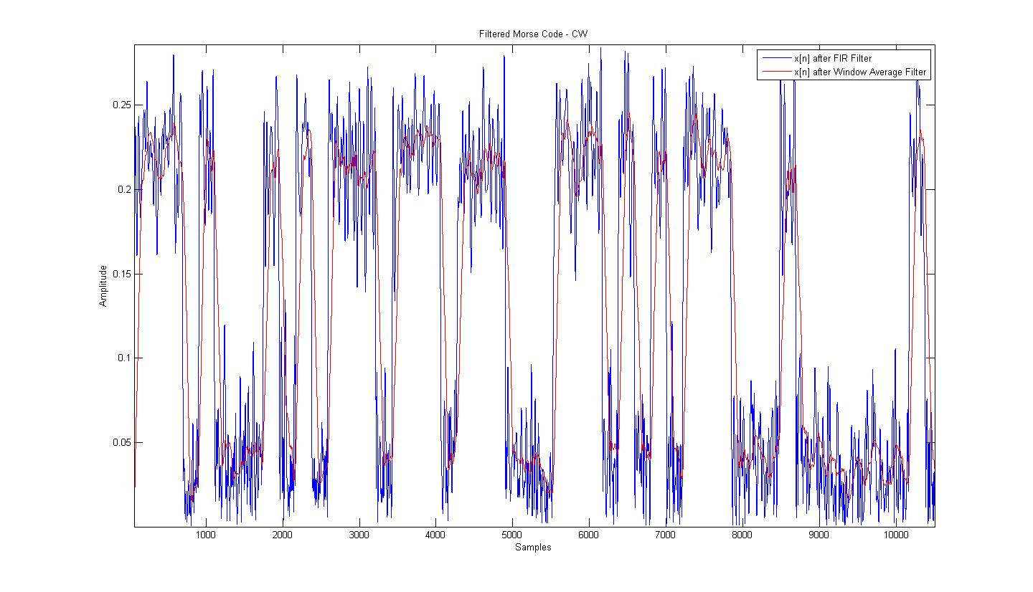

Figure : Effects of Window Averaging Filter

The output of the Window Averaging Filter compared with the orignial Morse Code Pulse is shown in Figure 9: Performance of Morse Decoder at SNR= -3dB.

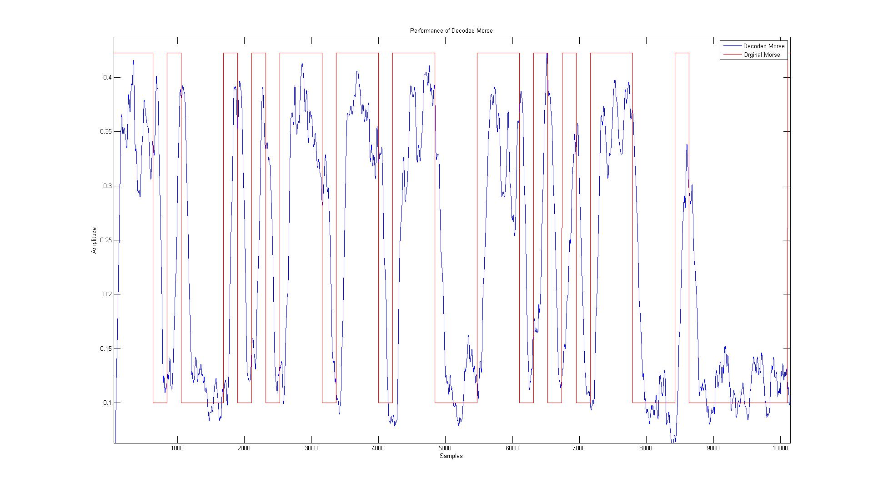

Figure : Performance of Morse Decoder at SNR= -3dB.

* 1. Magnitude Detect State Machine

The Magnitude Detect State Machine operates by monitoring the input signal, show above in , for a rising edge. This is done by comparing the average of N value to a defined **detect** value. Upon detection of a pulse high the state machine begins. The next state is to count the pulse width until the value drops below some pre-defined **reject** level (current software uses a reject level of ¼ the detect level). The state machine assigns the dit or dah value upon entry into the reject state depending on the length of time spent in the detect state.

1. References
2. [Wikipedia - Morse Code](http://en.wikipedia.org/wiki/Morse_code)
3. [FIR Basics](http://www.dspguru.com/dsp/faqs/fir)
4. [Implement FIR Filters](http://www.bores.com/courses/intro/program/7_filter.htm)
5. [Moving (Window) Averaging Filter](http://lorien.ncl.ac.uk/ming/filter/filmav.htm)
6. Appendix
   1. Max Serial Transmission Rate

A detailed explanation of Air Segment message is available in the SW-005-01 ICD Messaging Interface. The max serial transmission data rate of the Morse code ASCII characters over the serial output port.

Max (worst case) (8bit ASCI characters) = **1 character every 1.175seconds.**

**Calculation**

12WPM has an dit on time of 1.2/12 = 0.1 second dah = 0.3s, forced three dah’s between character.

Shortest (in time) possible message is the following twelve characters :

**U**P**QQ**A**B**C**AQ**AA**X**

**001** 0110 **1101** **1101** 01 **1000** 1010 **01 1101** 01 01 **1001**

**1.0s**+1.4s+**1.6s+1.6s**+0.8s+**1.2s**+1.4s+**0.8s+1.6s**+0.8s+0.8s+**1.1s** (time includes spaces between letters)

12 characters in 14.1 seconds.